**NSSA221 Systems Administration I**

**Lab 02 Report**

# Name: Edwin Chen Grade ____/100

All screenshots in the report must be labeled with the provided titles. Each screenshot is worth 10 points, and a minimum of 70 points is required to pass the lab. This means no more than three screenshots can be missing.

Ensure each screenshot contains all required information. If any information is missing, or if the screenshot is illegible, blurry, or unreadable, you will not receive credit. Altering screenshots in any way constitutes academic dishonesty and may result in failing the course.

Figure 1 – Active Directory Validation

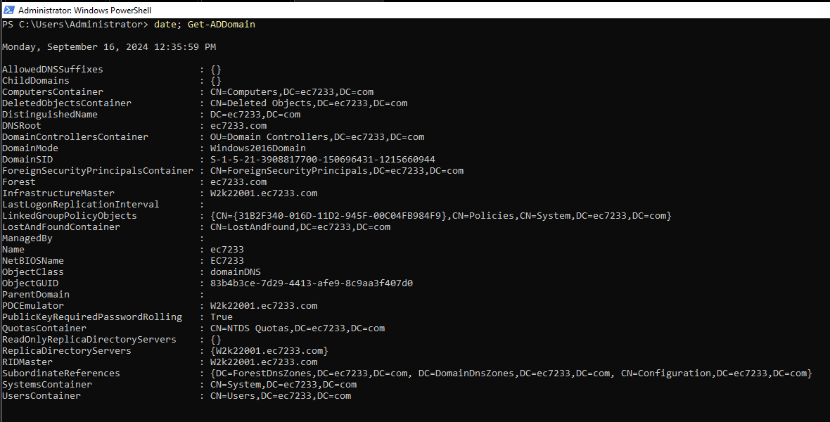

Figure 2 – Domain Controller and DHCP Scope Verification

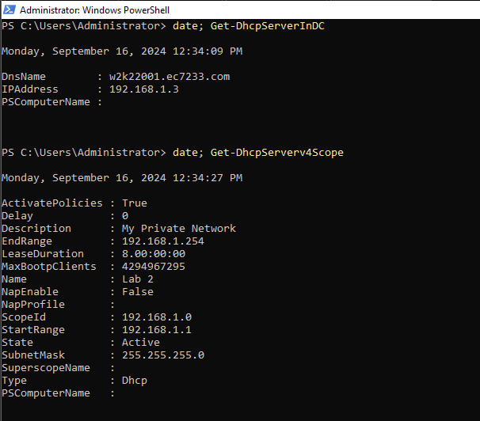

Figure 3 – Windows 10 DHCP Validation

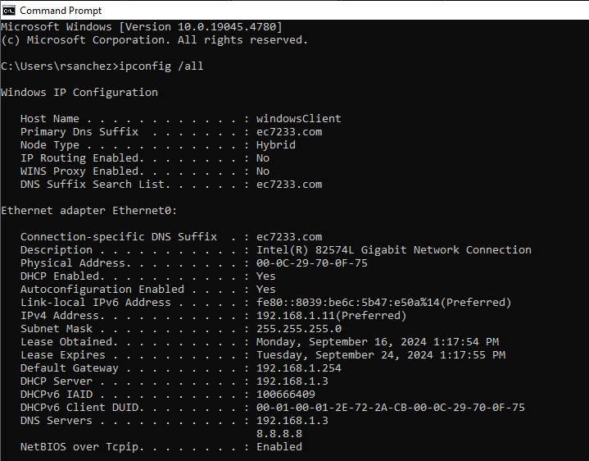

Figure 4 – Windows 10 Domain Verification

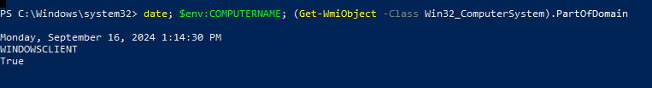

Figure 5 – Linux Domain Verification

Figure 6 – Get-ADDomain PowerShell Session Output

Figure 7 – First Organizational Unit

Figure 8 – Second Organizational Unit

Figure 9 – PowerShell History

Figure 10 – GPO Reports*

*If you need multiple screenshots for the GPO reports just append a letter, for example, Figure 10a, Figure 10b.